**Part 1: Search Engine Optimization (40%)**

*Part 1a: Content (25%)*

We analyzed the home page, collections/all page, Chinese Chicken soup page, Vietnamese Beef pho page, and Korean Oxbone soup page. All the pages except for the home page were being viewed as intended. However, the content of each page could be further optimized for search by improving the keywords in each page.

Googlebot does not see the home page as intended. Content on how nomz works does not show up. See Figure 1.

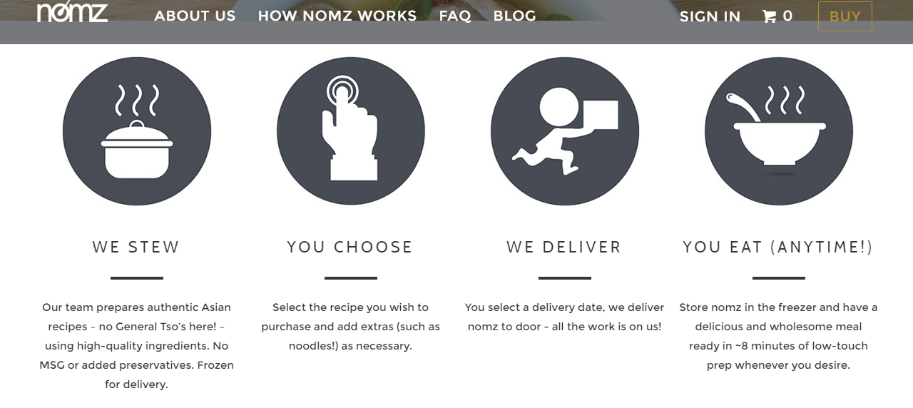

Figure 1: How Nomz Works content on home page is not seen by Googlebot

Furthermore, individual product information on the home page is not seen by Googlebot either (See Figure 2). The home page of the website requires significant changes and improvements. The home page should have more keywords such as “Frozen Asian Food”, “Convenient meal solutions”, or “Frozen food products” in paragraphed text descriptions. This will not only improve the information design of the website, but also allow search engines to index the homepage more effectively.

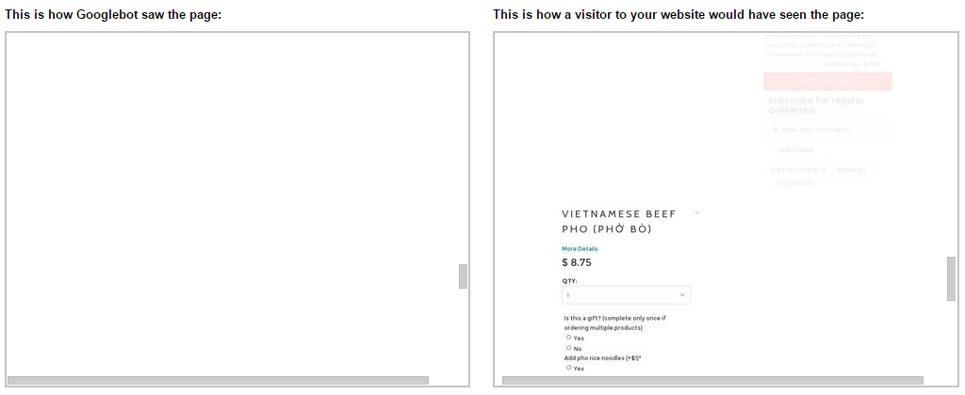

Figure 2: Googlebot does not see individual product information on home page

Similarly, we ran a TFIDF analysis on the 5 pages, home page, collections/all, Chinese chicken shiitake mushroom soup, Vietnamese beef pho, and Korean Oxbone soup. Appendix 1 shows a summary of the keywords we searched for each page. The pages in general performed well against the competing pages in their TFIDF values. Figure 3 is a summary of keywords that should be added to the respective pages to improve TFIDF standings.

For the home page, keywords such as “mushroom”, “oxbone”, and “nomz” performed relatively better than competing pages. Unfortunately, keywords such as “frozen”, “delivery”, and “traditional” performed much more poorly relative to competing pages.

For the collections/all page, the word “noodle” performed extremely poorly as relative to its competing pages. This was also the case for “soups”, and “Asian”.

For the Chinese chicken mushroom soup page, Chinese spelling words such as “xiang”, “gu”, “ji”, and “tang” performed well. The word “dates” performed well too. However, this was due to the fact that such words did not really appear in any other documents. It was troubling that the word “chicken” performed very poorly. This would affect page rank when users search for chicken soup.

For the Vietnamese pho soup page, the words “beef” and “pho” performed relatively well.

For the Korean Oxbone soup page, the words “soup”, “sul”, and “tang performed relatively well.

|  |  |
| --- | --- |
| **Page** | **Keywords** |
| Home Page | “Frozen Asian food”, “Asian food products”, “frozen Asian cuisines”, “Frozen Asian food products”, “Asian soup products”, “convenient meal solutions”, “alternative to convenient meal solution”, “nutritious”  **Make key words appear more often in the homepage. |
| Collections all | Repeat occurrence of words of product titles by having a very short summary of each product |
| Chinese Chicken Shiitake Mushroom Soup | “Frozen”, “Convenient meal”, “Pre-cooked”, “gourmet soup”, “heat and serve”, “quick lunch or dinner”, “instead of using microwave, we recommend heating on a stove for a more wholesome/authentic taste”  ** Title is too long. Shorten it. Add specific details in bullet points  ** Again, layout of page provides low readability. Perhaps, refer to Annie Chun’s product layout as an example. <https://anniechun.com/anniechun-soup-bowl/> |
| Vietnamese Beef Pho | “Frozen”, “Convenient meal”, “Pre-cooked”, “gourmet soup”, “heat and serve”, “quick lunch or dinner”, “instead of using microwave, we recommend heating on a stove for a more wholesome/authentic taste” |
| Korean Oxbone Soup | “Frozen”, “Convenient meal”, “Pre-cooked”, “gourmet soup”, “heat and serve”, “quick lunch or dinner”, “instead of using microwave, we recommend heating on a stove for a more wholesome/authentic taste” |
| About us | “Nomz, Inc.”, “Eatnomz”  **Perhaps change page title to “About Nomz”, “our story” to “the nomz story”, “our team to “the nomz team” |

Figure 3: List of keywords to be added to pages for SEO

In addition to the list of keywords that could be added to the pages. The home page could be further search engine optimized by adding snippets of customer reviews, containing words such as “quick and easy”, “delicious, healthy, and convenient”, and “a satisfying meal”. Having more customer reviews on each individual products page will also definitely improve keywords TFIDF of pages.

*Part 1b: Linkage (15%)*

*1. Use the online Page Rank checker (http://www.prchecker.info) to attain the Page Rank for your home page and 2-3 additional pages. Home page scores of 3-4 or higher are considered good for small business/non-profit websites. Lower scores can be problematic. The higher, the better. Report the results in a table.*

All our pages have been indexed correctly, but the page rank is zero for all of them. Keywords SEO changes will hopefully improve the page rank.

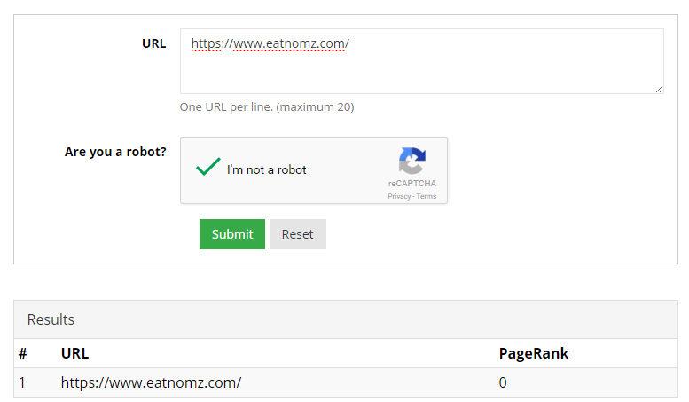

Figure 4: Page rank of nomz home page

*2. Use Google Webmaster tools to examine the present in-links for your website. Download the in-links table as a CSV file. Which in-links appear to be contributing the most to your home page’s Page Rank?*

An analysis of the in links to the website shows that **ink361.com** and **websta.me** are bringing the most traffic to the home page.

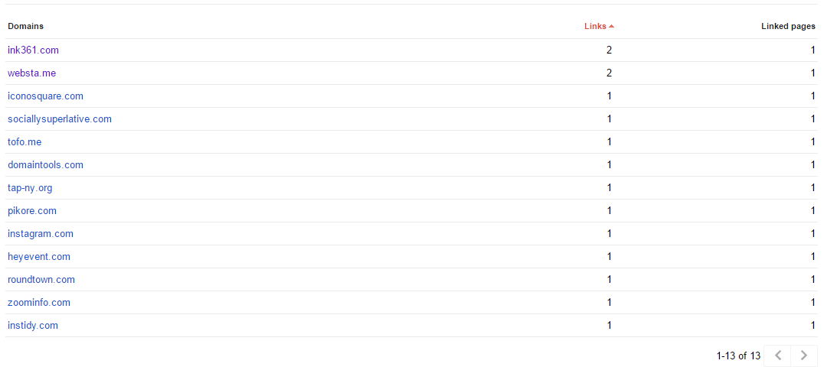

Figure 5: in-links contributing to home page’s page rank

*3. Identify at least 5 additional websites, blogs, social media sources, and/or forums that could serve as good potential outlets to place links pointing towards your website.*

*Examples include Google+ page, Yelp, TripAdvisor, Facebook Fan Page, etc.*

*4. For the pages identified in #3, create in-links for your home page on as many as possible. Google + is absolutely essential for SEO! Note- some of these might need to verify your business via phone or mailed verification code (e.g., Google +). You’ll want to get this done before the GOMC to improve search visibility and rankings (organic and paid search).*

*5. Use Google Webmaster tools to see how many of the in-links created have been included in Google’s index.*

*6. Identify and remove unnecessary out-links (if any) that are “leaking” PageRank to nonaffiliated external site’s pages. Important widgets (e.g., Google Maps) are generally not considered unnecessary out-links.*

Appendix 1: Pages and Keywords searched

|  |  |
| --- | --- |
| **Page** | **Keyword** |
| Home | EatNomz, Eat Nomz, Nomz, Asian Soups, Wholesome Asian Soups, Traditional Soup, Soup Delivery, Frozen Soup, Soup, Shitake Mushroom Soup, Beef Pho, Oxbone Soup |
| Collections/all | Shiitake Mushroom Soup, Beef Pho, Oxbone Soup, Asian Soups, Wholesome Asian Soups, Traditional Soup, Soup, Noodle Soup, Asian Noodle Soup, Soup with Noodles, ji tang, xiang gu ji tang, pho bo, sul lun tang, PHỞ BÒ |
| Vietnamese beef pho | Beef Pho, Vietnamese Beef Pho, Vietnamese Pho, Pho, Pho and Noodles, Pho and Rice, Pho Rice Noodle, Traditional Pho, Authentic Pho, Healthy Pho, Traditional Beef Pho, Authentic Beef Pho, Healthy Beef Pho, Traditional Vietnamese Pho, Authentic Vietnamese Pho, Healthy Vietnamese Pho, Pho Bo, Pho Delivery, Beef Pho Delivery, Vietnamese Pho Delivery, Vietnamese Beef Pho Delivery, PHỞ BÒ |
| Chinese chicken shiitake mushroom soup | Shiitake Mushroom Soup, Chinese Shiitake Mushroom Soup, Chinese Soup, Chinese Chicken Soup, Chicken Soup, Chicken Shiitake Mushroom Soup, Chinese Chicken Shiitake Mushroom Soup, Chinese Noodle Soup, Chinese Chicken Noodle Soup, Xiang Gu Ji Tang, Ji Tang, red dates soup, goji berries soup, goji berries, goji berry, chinese noodles soup, chinese soup noodles, chinese chicken noodles soup, chicken noodles soup, chicken soup with noodles, chicken soup noodles, shiitake mushroom Traditional Chinese Shiitake Mushroom Soup,  Authentic  Chinese Shiitake Mushroom Soup, Healthy  Chinese Shiitake Mushroom Soup, Traditional Chinese Shiitake Chicken Soup, Authentic Chinese Chicken Soup, Healthy Chinese Chicken Soup, Traditional Chinese Chicken Soup, Authentic Chinese Shiitake Chicken Soup, chinese chicken soup delivery, chicken soup delivery, ji tang delivery, xiang gu ji tang delivery, xianggu ji tang, xiang gu jitang |
| Korean Oxbone soup | Korean Oxbone Soup, Oxbone Soup, Korean Soup, Oxbone, Oxbone Soup and Noodle, Korean Oxbone Soup and Noodle, Korean Oxbone Soup and Rice, Oxbone Soup Noodle, Traditional Oxbone Soup, Authentic Oxbone Soup, Healthy Oxbone Soup, Traditional Korean Oxbone Soup, Authentic Korean Oxbone Soup, Healthy Korean Oxbone Soup, Traditional Korean Soup, Authentic Korean Soup, Healthy Korean Soup, Sul Lun Tang, Oxbone Soup Delivery, Sul Lun Tang Delivery, Korean Oxbone Soup Delivery |

Appendix 2: Pages Keywords TFIDF Performance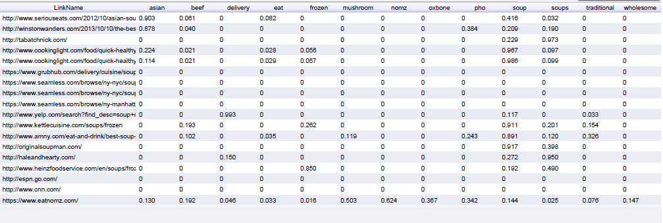

Homepage TFIDF

Collections All TFIDF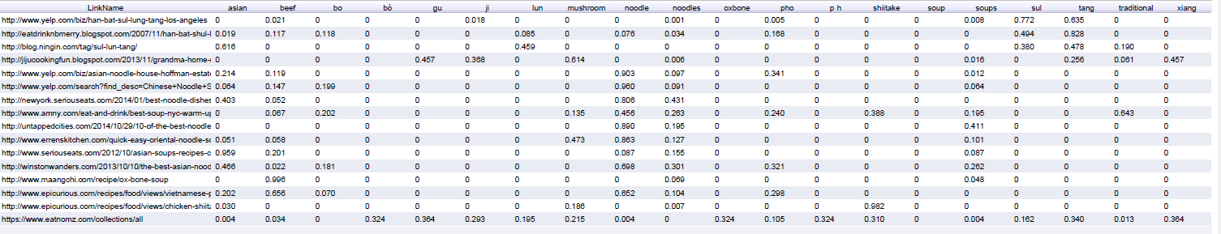

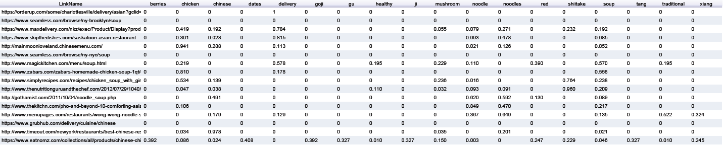

Chicken Mushroom Soup TFIDF

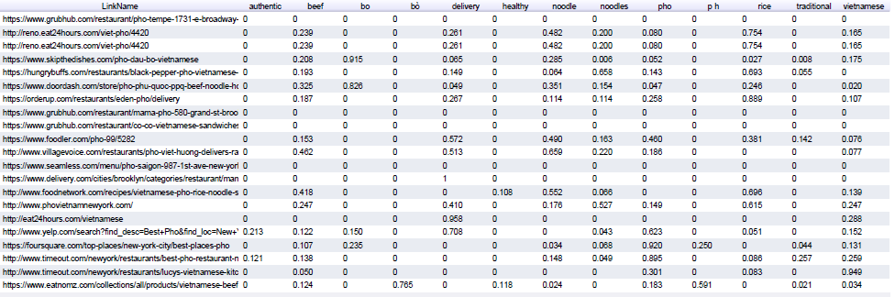

Vietnamese Beef Pho Soup TFIDF

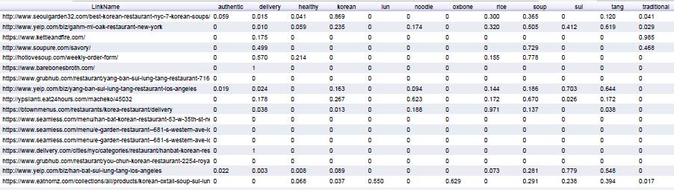

Figure8: Korean Oxbone Soup TFIDF